

**Pheidip Shop**

|  |  |  |
| --- | --- | --- |
| **Supervisor:** | *LÊ THANH NHÂN* | |
| **Semester:** | *II* | |
| **Batch No:** | *T1.2112.E0* | |
| **Group No:** | *5* | |
| **Order:** | **Full name** | **Roll No.** |
| *1.* | *Hứa Lê Quang* | *Student1350321* |
| *2.* | *Lê Vĩnh Phước* | *Student1352185* |
| *3.* | *Trần Hải Phong* | *Student1350323* |
| *4.* | *Trần Lê An* | *Student1350324* |
| *5.* | *Trần Nam Trung* | *Student1350800* |

***Month****: 10* ***Year****: 2022*



This is to certify that

|  |  |
| --- | --- |
| **Mr.** | **HỨA LÊ QUANG** |
| **Mr.** | **LÊ VĨNH PHƯỚC** |
| **Mr.** | **TRẦN HẢI PHONG** |
| **Mr.** | **TRẦN LÊ AN** |
| **Mr.** | **TRẦN NAM TRUNG** |

Have successfully Designed & Developed

|  |  |  |
| --- | --- | --- |
|  |  |  |
| **PHEIDIP SHOP** | | |

Submitted by:

|  |
| --- |
| **Mr. LE THANH NHAN** |

Date Of Issue:

|  |  |
| --- | --- |
|  |  |

Authorized Signature:

|  |  |
| --- | --- |
|  |  |
| **Content** | | | |

Content

Acknowledge

Synposis

Review1 1

Review2 6

Review3 21

Testing Document 46

Final Checklist 47

Tasksheet 48

|  |
| --- |
| **Acknowledge** |

We would like to send a great thank to our professor, Mr Le Thanh Nhan and others student for the adorable supports during the time in project. Beside several mistakes we had made in the project, we hope to have more opportunities to widen our knowledge in web developing world. We also thank you so much for the information and the “demo” project from India APTECH to help us get more reality experience in this project. Since we have gained more experience from this project, we will not stop learning more as much as we can to be more successful in the future.

Your Sincerely,

Group 5

|  |
| --- |
| **Synopsis** |

The goal of this project, Pheidip Shop is to give a sample of a ecommerce-website that has some main function of a real life website.

We will build this website with what we learned in semester II. PHP and MySQL will be used in our project. This project will give an overview of how an ecommerce-website works, the way that the data transfer between database and front end.

Pheidip Shop contains three main features:

* User can use their own account for shopping.
* A convenience shopping experience with shopping cart
* Website administrator can manage user accounts, products and orders.

All the experiences we achieve when building this project will be very helpful for us in the future works.

**Review 01**

|  |
| --- |
| **Problem Definition** |

Since the rise of large internet-based e-commerce sites, the growth of online shopping has been exponential, with a huge increase in the number of consumers choosing to buy online rather than in-store. Many traditional retailers have also followed suit, with most shops now having a dedicated e-commerce website from which consumers can make online purchases, from high street brands to charities. Even brands which no longer exist on the high street are often available online.

Pheidip Shop, an e-commerce sites for shoes, which will provide various choices for customer, with famous brands like Nike, Adidas, Timberland, Dr. Martens,… Users can easily create their account and purchase the best products from the shop.

**Problem:**

* Provide information of products for customer.
* Receive feedback from customer.
* Admin can quickly update information of products.
* Admin can easily manage user accounts.
* Customer can take many products in their cart and get a bill.
* Customer can check their purchase history.

|  |
| --- |
| **Customer Requirements Specifications** |

**User:**

* Input:
* Register information of users
* Purchase information
* Send feedback
* Process:
* Check register information
* Find products information
* Create orders
* Save feedback
* Output:
* Successfully registered notification
* Cart information
* Successfully send feedback notification

**Admin:**

* Input:
* Login information of admin account
* Add/update information of product
* Add/update information of brands
* Delete information of user account
* Process:
* Check login information of admin account
* Add/update products
* Add/update brands
* Delete user account
* Output:
* Successfully login notification
* Successfully add/update products
* Successfully add/update brands
* Successfully add/update/delete user account

**System requirements:**

|  |  |
| --- | --- |
| Hardware: | Software: |
| Server:   * Pentium 4, 1.8 Ghz or better * 512 MB of RAM * 300 MB of HDD capacities available   Client:   * Pentium III, 500 Mhz   265 MB of RAM | Server:   * OS with Windows XP SP2 * IE 5.0/Netscape 6.0 * MySQL Server 2008 or later   Client:   * IE 5.0/Netscape 6.0 |

**Review 02**

|  |
| --- |
| **Data Flow Diagram** |

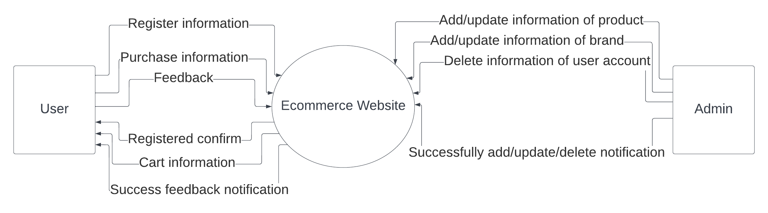

|  |
| --- |
| **A. Entity Relationship Diagram** |

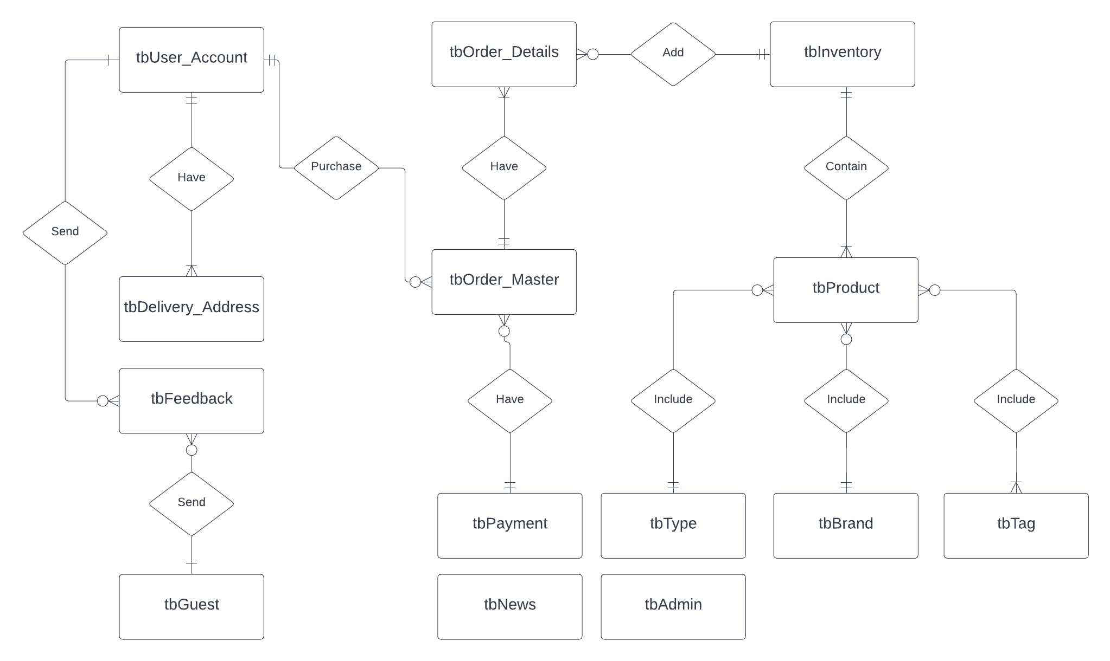

|  |
| --- |
| **B. Entity Attributes** |

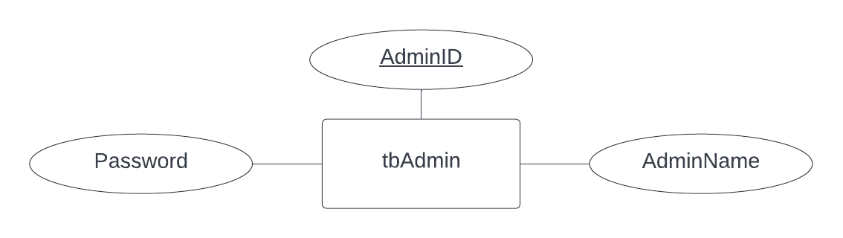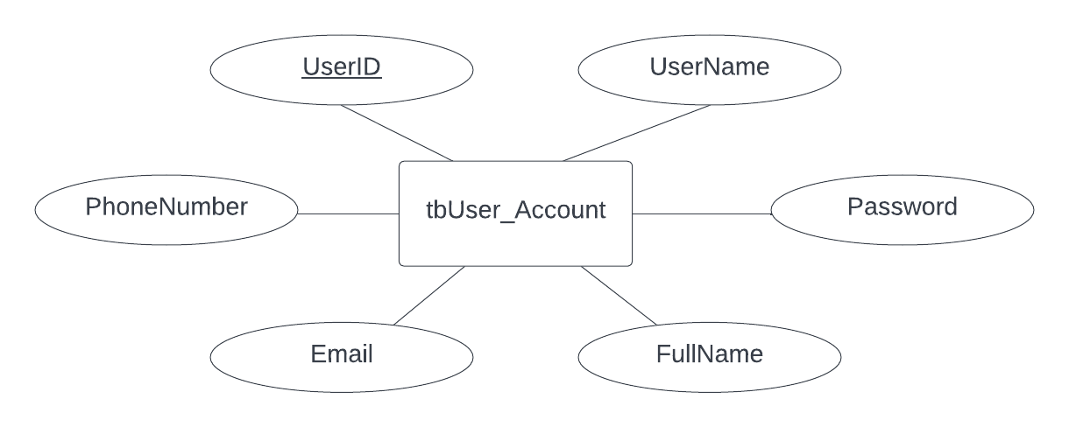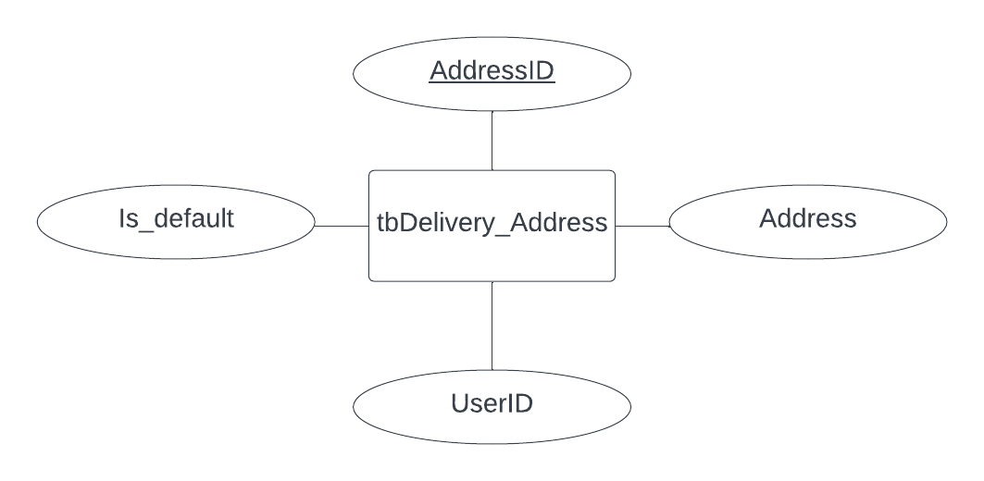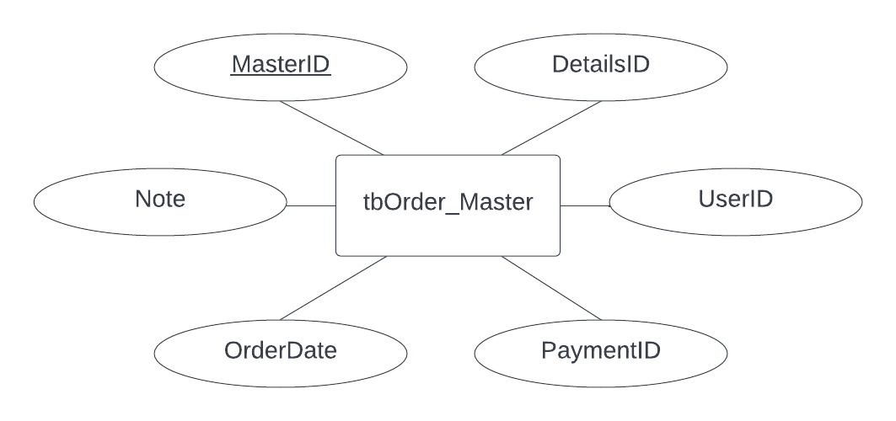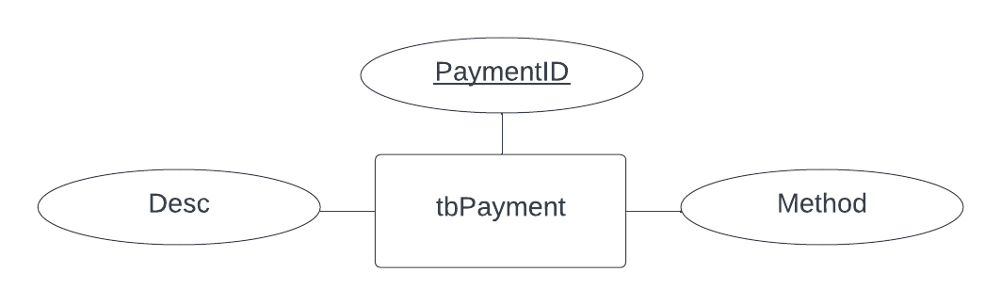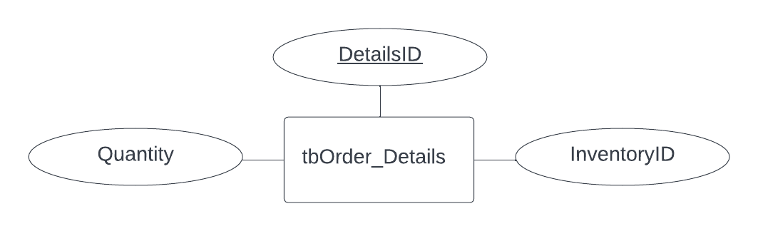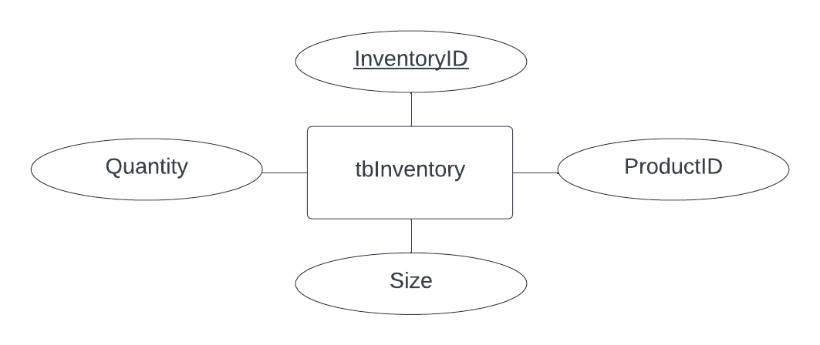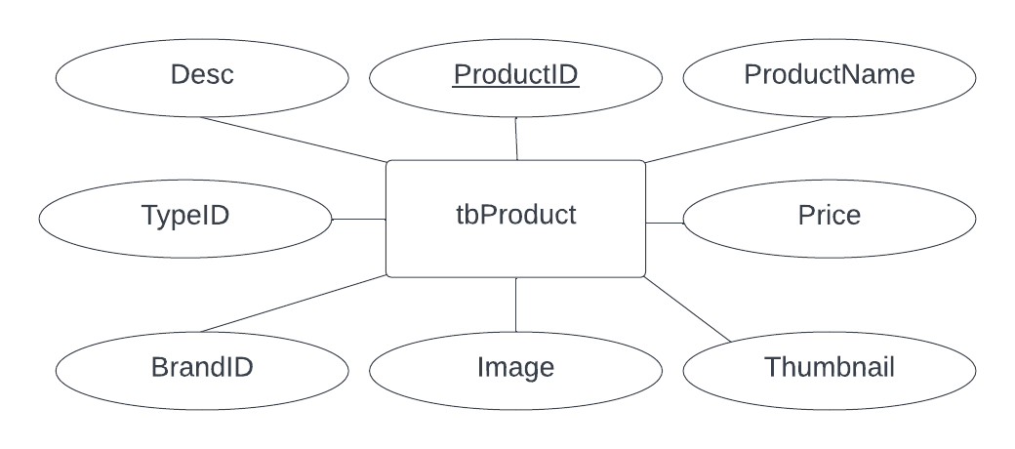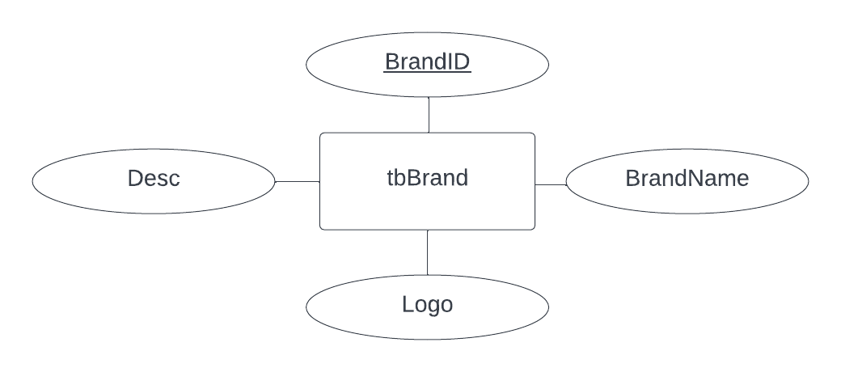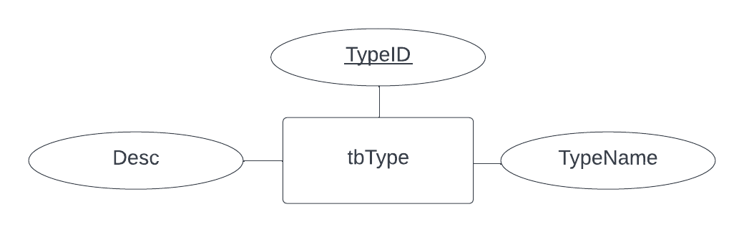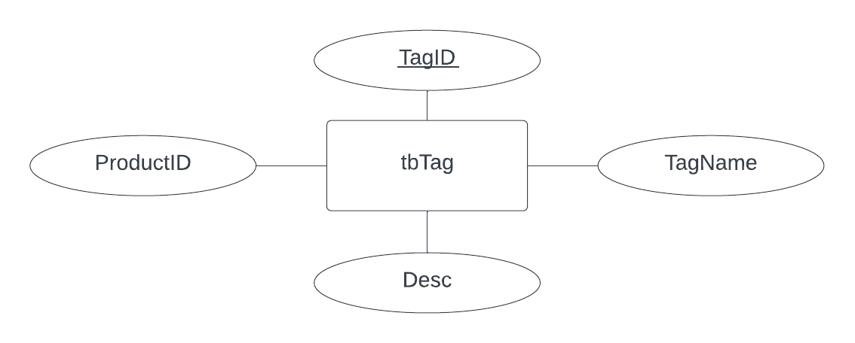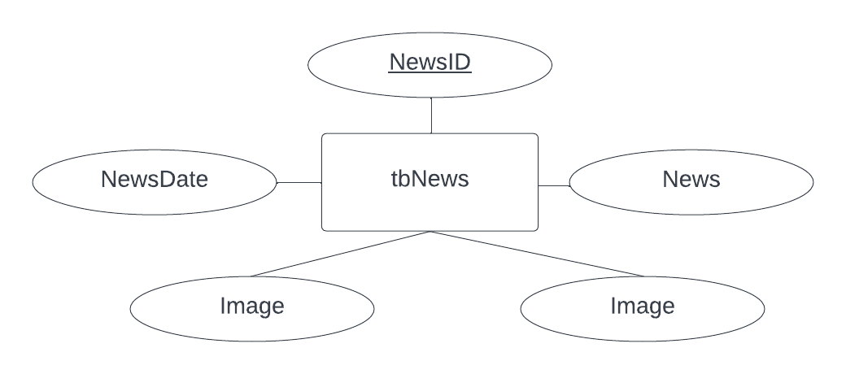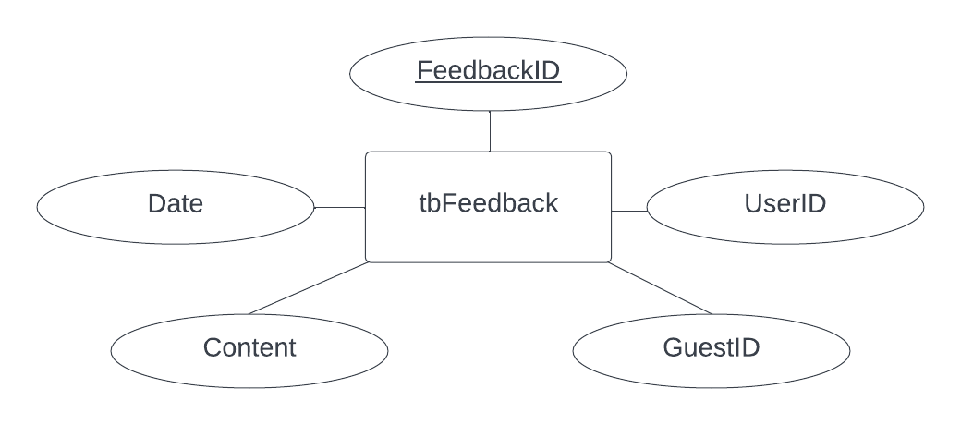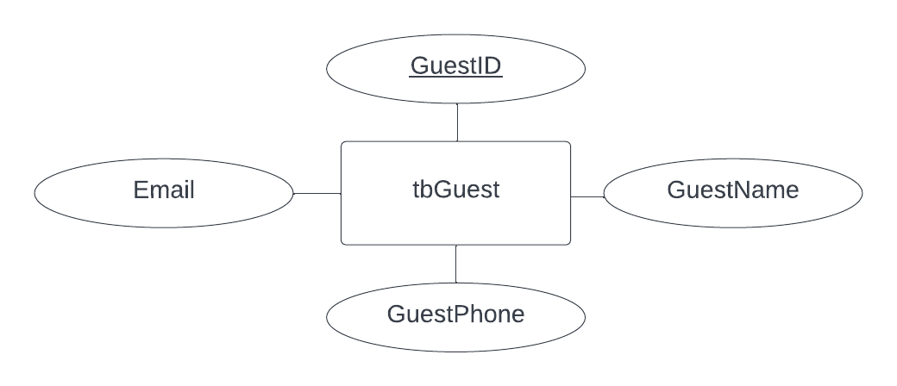

|  |
| --- |
| **A. Table Design** |



|  |
| --- |
| **B. Relationship Diagram** |

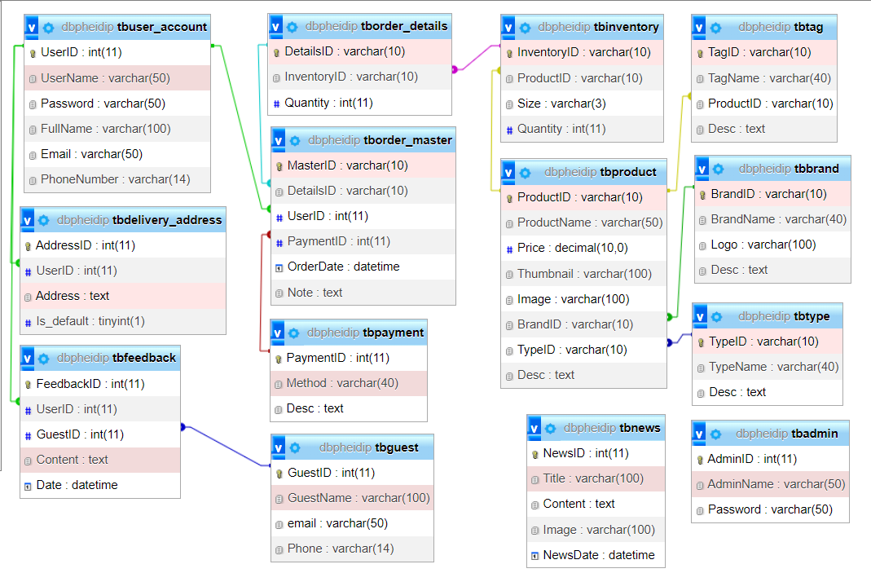

|  |
| --- |
| **SiteMap** |

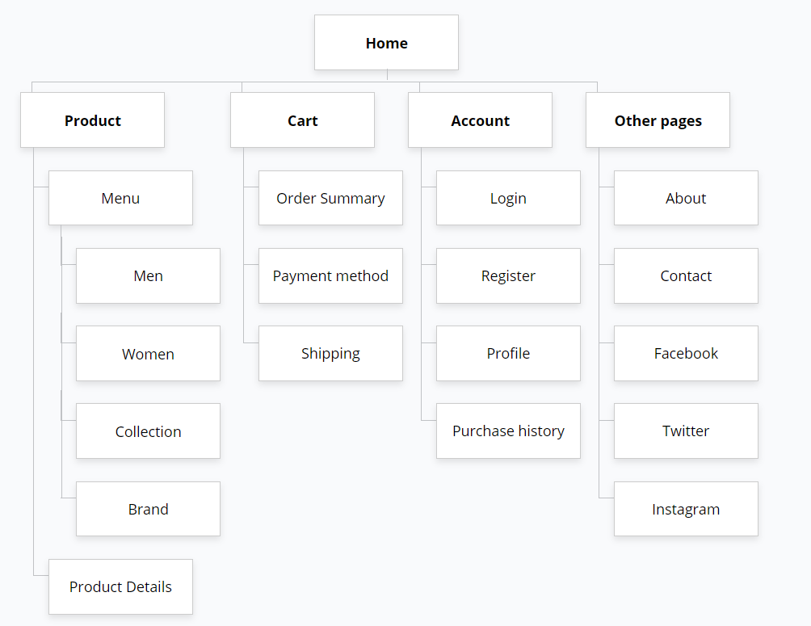

|  |
| --- |
| **Algorithm** |

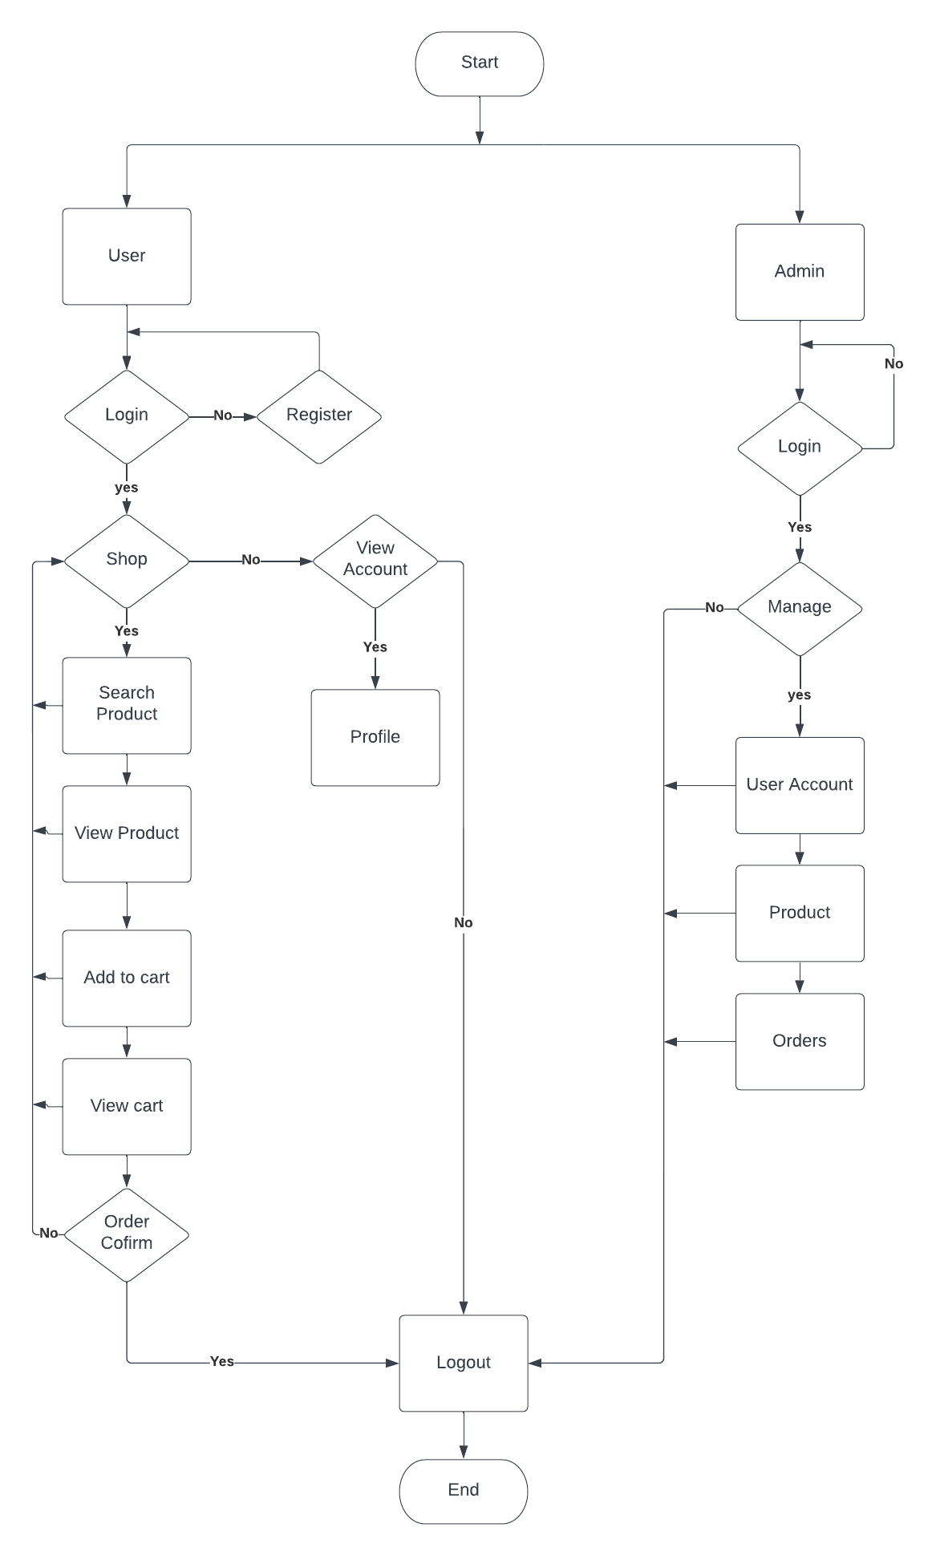

**Review 03**

|  |
| --- |
| **Screen shots** |

**A. USER**

**I. Homepage:**

1. **Screenshot**

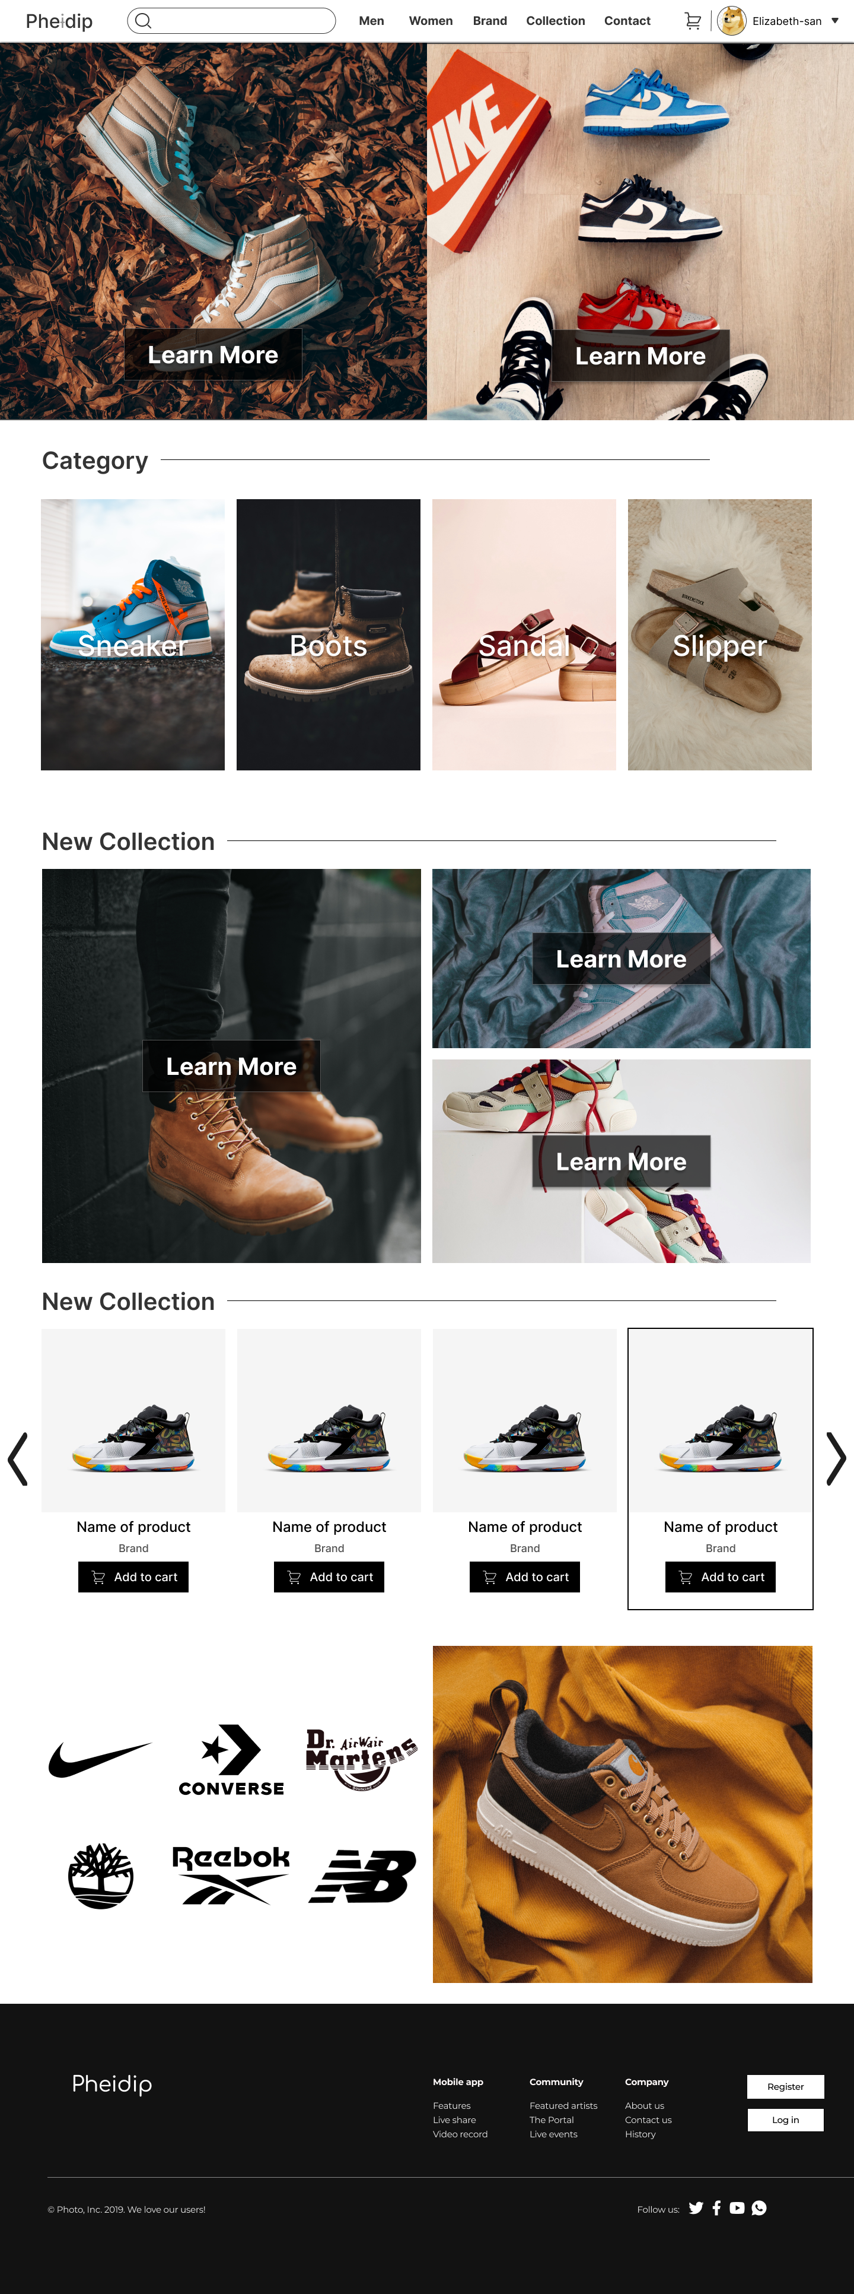

1. **Description**

**Description** : Home page, display news, category and links to others page

**From** : Login page or Register Page

**To** : Login page, Register page, Product page, Brand page, Collection page, Contact Us, Cart, User Profile.

**II. Login**

1. **Screenshot**

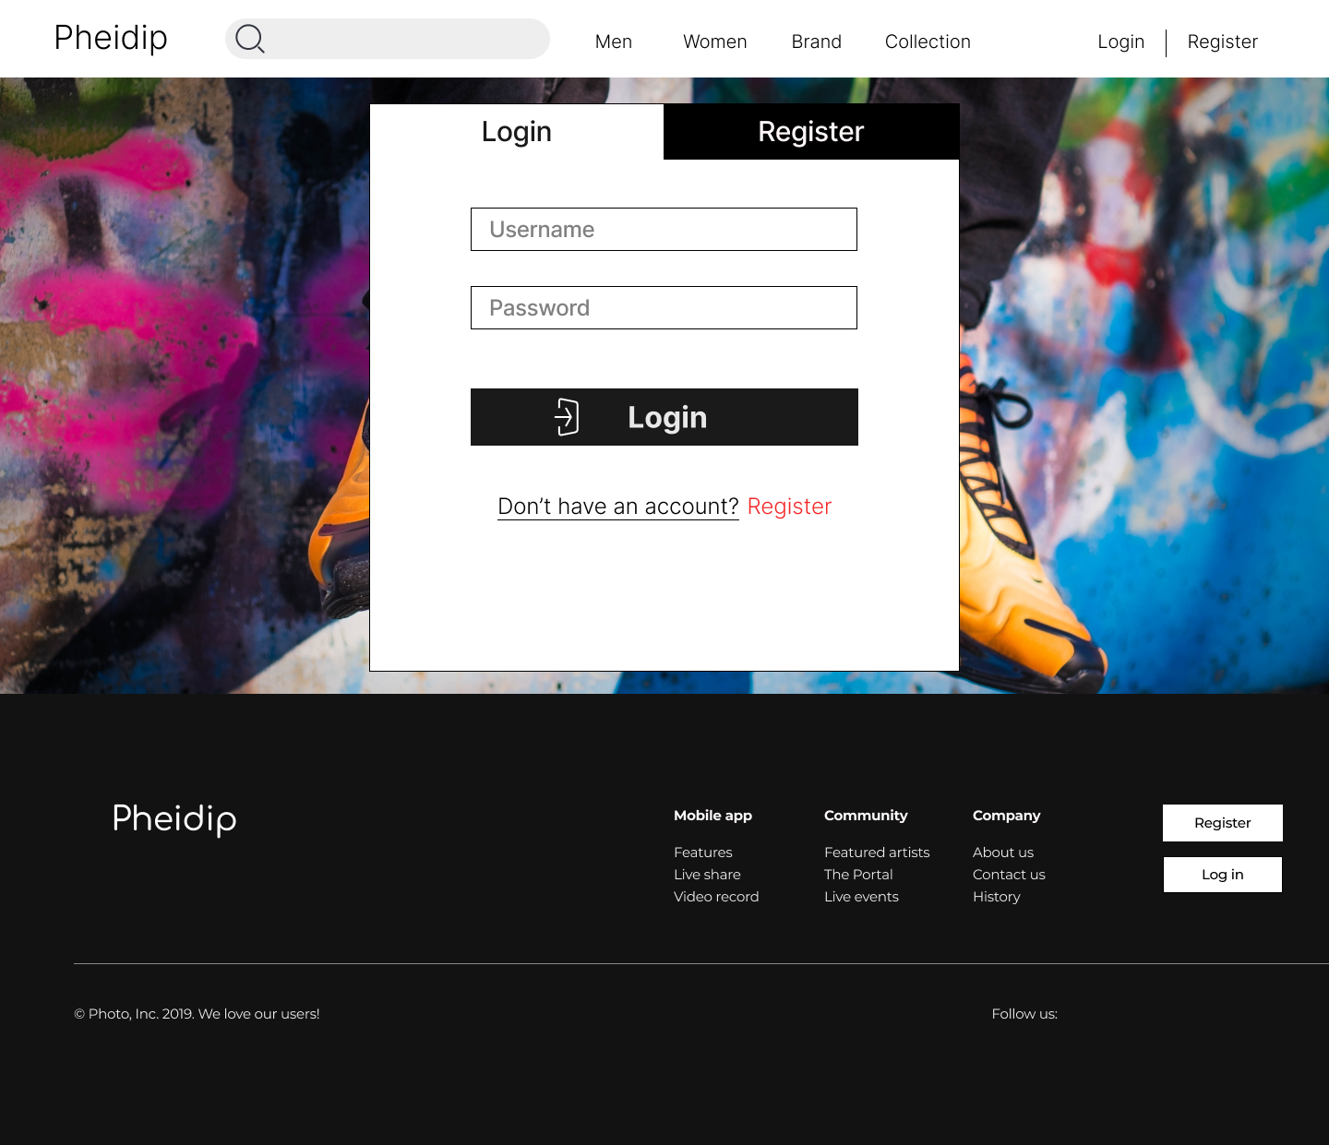

1. **Description**

**Description** : Login page, for login function

**From** : Home page

**To** : Home page, Register page

**III. Register**

1. **Screenshot**

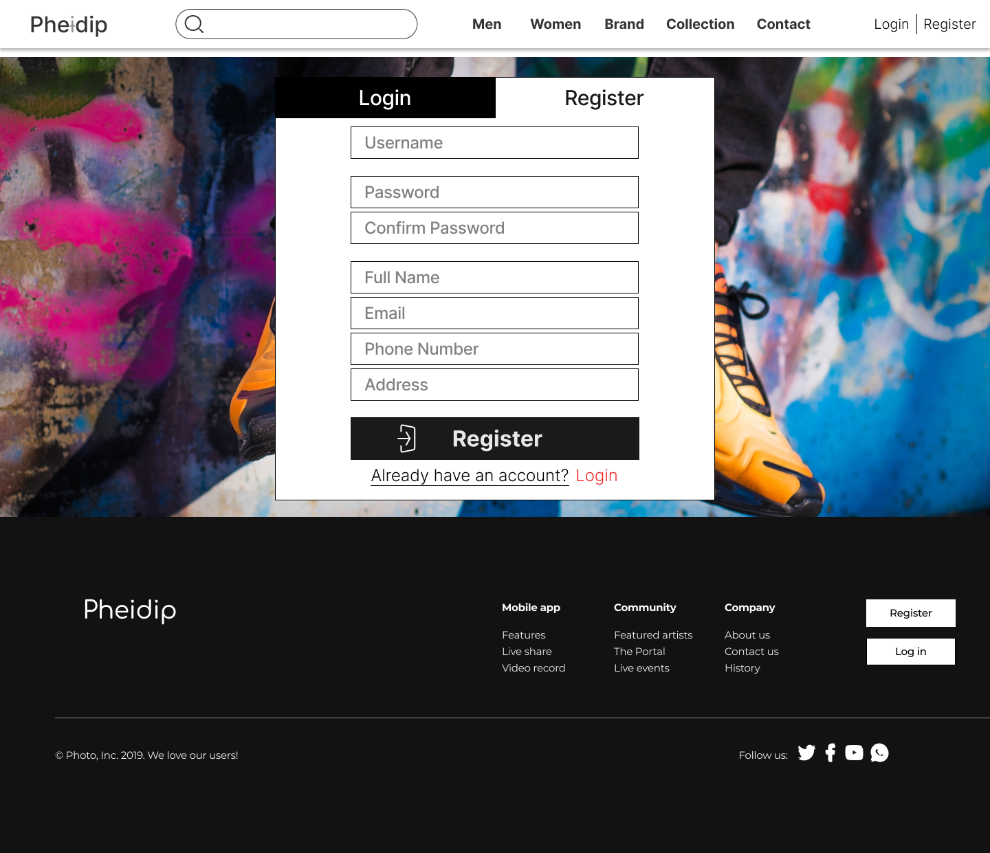

1. **Description**

**Description** : Register page, for user create an account. All input is required. Username, email, phone number are unique. Username can contain uppercase/lowercase letters, numbers and from 6 to 20 characters. Password must contain at least one  number and one uppercase and lowercase letter, and at least 8 or more characters. Full Name only contain uppercase or lowercase letters and at least 3 or more characters. Email characters followed by an @ sign, followed by more characters, and then a ".". After the "." sign, add at least 2 letters from a to z. Phone number only contain numbers and at least 10 digits or more.

**From** : Home page, Login page

**To** : Login page

**IV. Product**

1. **Screenshot**

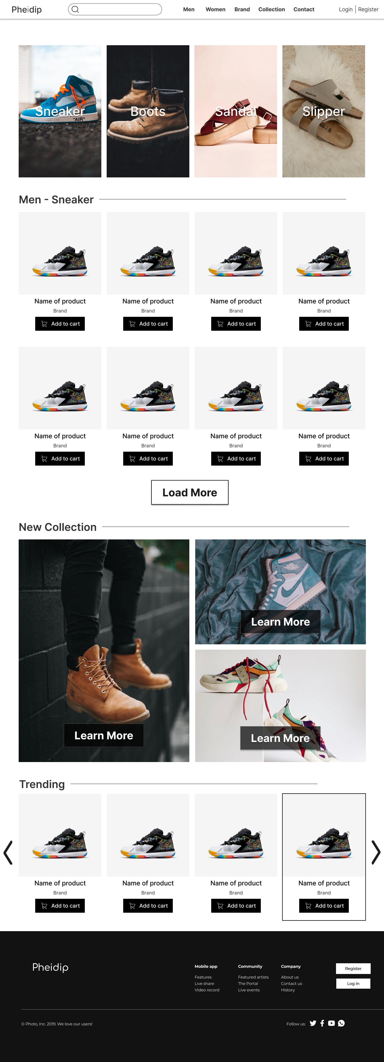

1. **Description**

**Description** : Product page, display product in categories

**From** : Home page

**To** : Product Details page, Cart

**V. Brand**

1. **Screenshot**

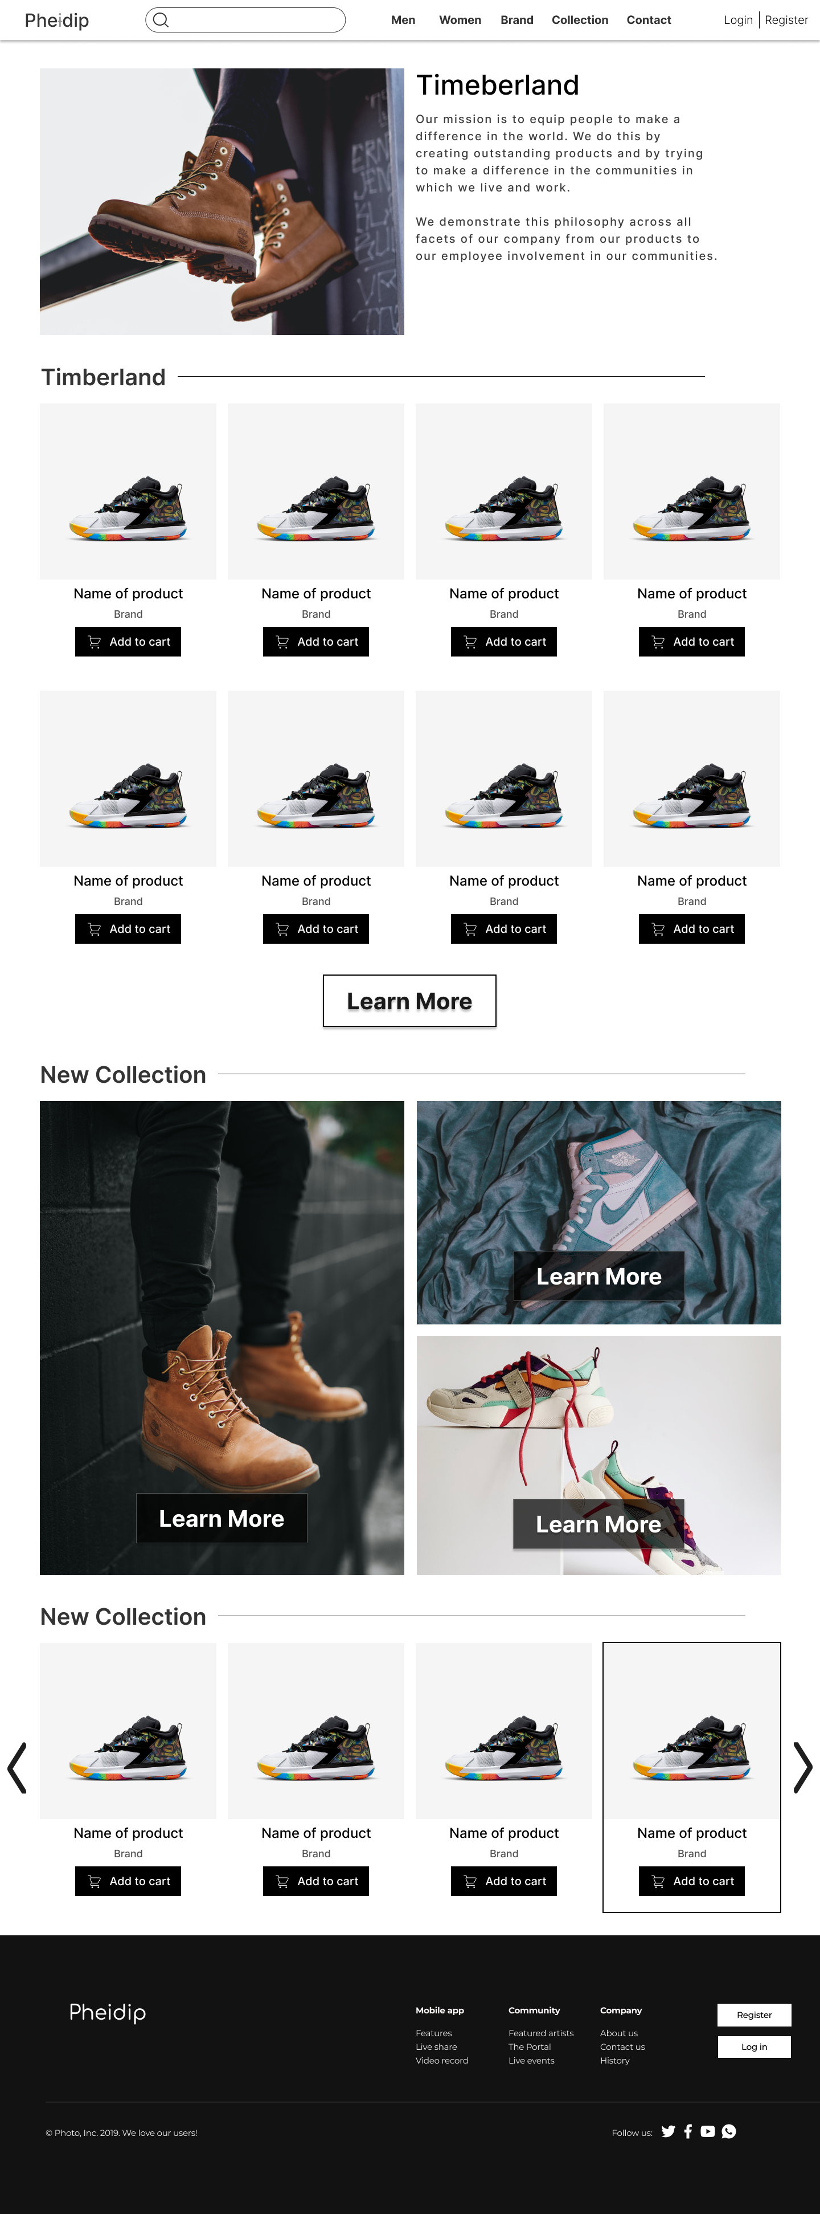

1. **Description**

**Description** : Brand page, display information of a brand and its products.

**From** : Home page

**To** : Cart

**VI. Cart**

1. **Screenshot**

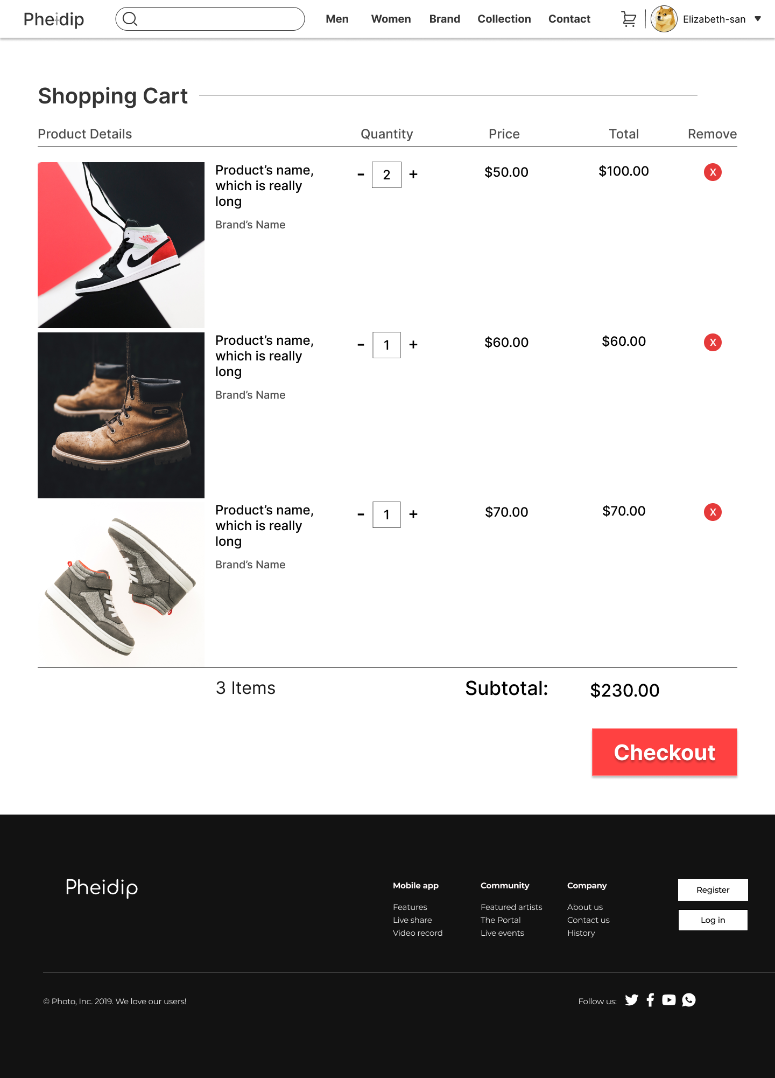

1. **Description**

**Description** : Cart page, display shopping cart of a user. It contains product details, price and remove function. Quantity of products must be equal or less than quantity in inventory.

**From** : Home page, Product page, Brand page, Collection page

**To** : Checkout page, Home page.

**VII. Checkout**

1. **Screenshot**

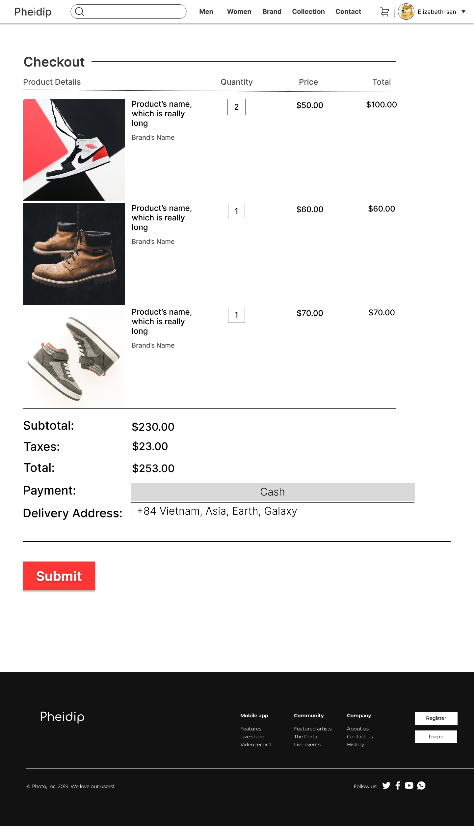

1. **Description**

**Description** : Checkout page, confirm orders, payment method and delivery address

**From** : Cart page

**To** : Home page

**VIII. User Profile**

1. **Screenshot**

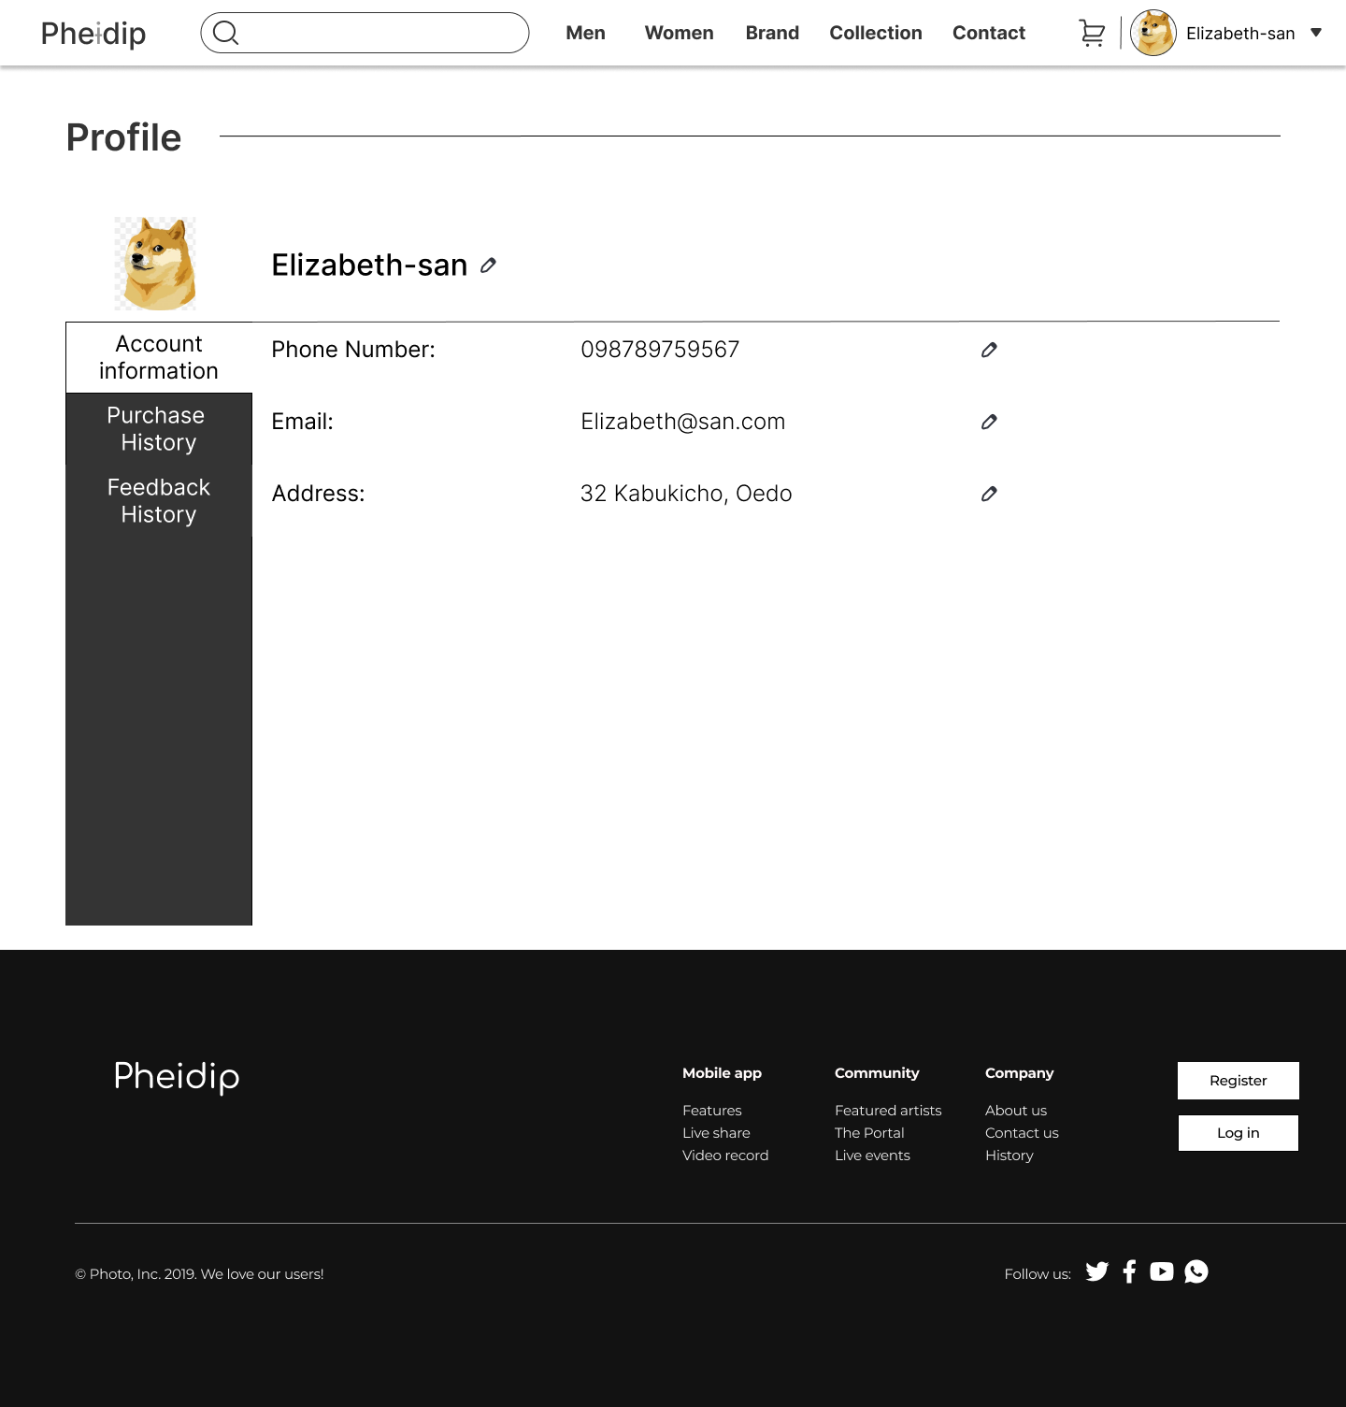

1. **Description**

**Description** : User Profile, display personal information of user, purchase history and feedback history. User can change personal information.

**From** : Home page

**To** :Home page

**IX. Contact**

1. **Screenshot**

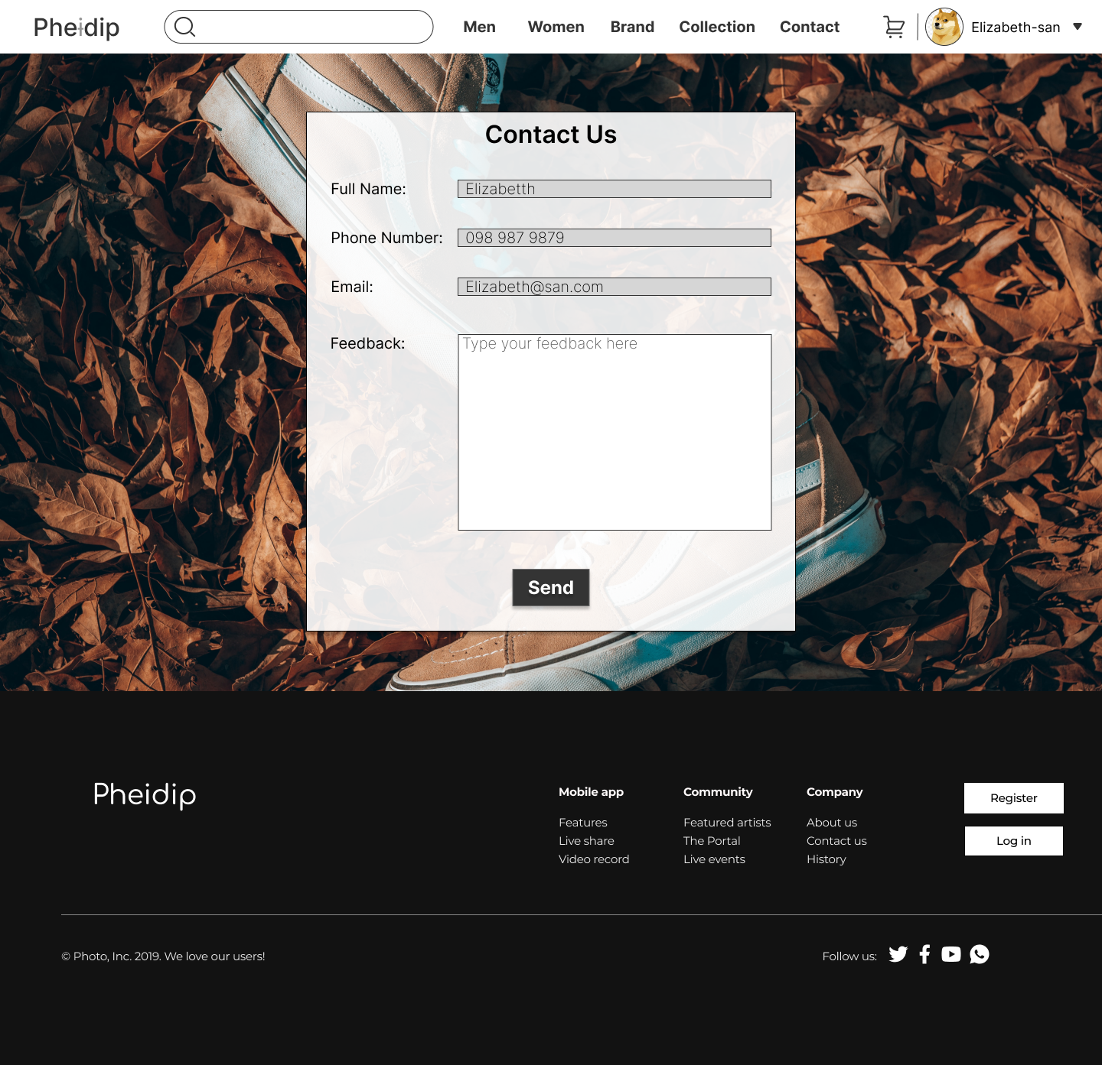

1. **Description**

**Description** : Contact page, for users and guests sending feedback. For guests who haven’t created an account, Full Name, Phone Number and Email must be filled.

**From** : Home page

**To** : Home page

**X. Product Details**

1. **Screenshot**

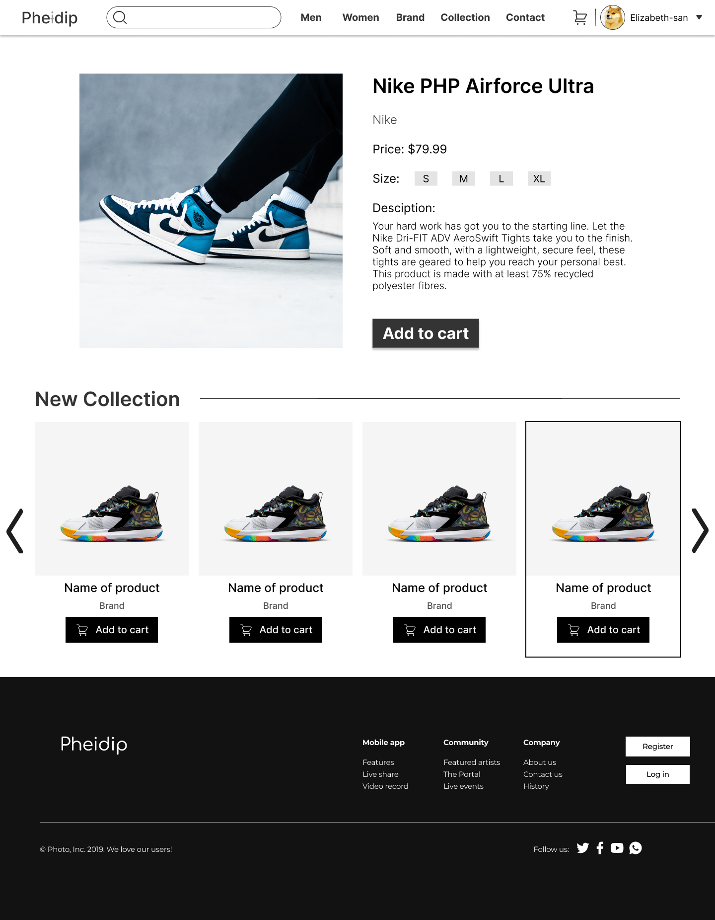

1. **Description**

**Description** : Product Details page, display details of a product

**From** : Home page, Product page, Brand page, Collection page

**To** : Home page, Cart page

* **ADMIN**

**I. Product Management**

1. **Screenshot**

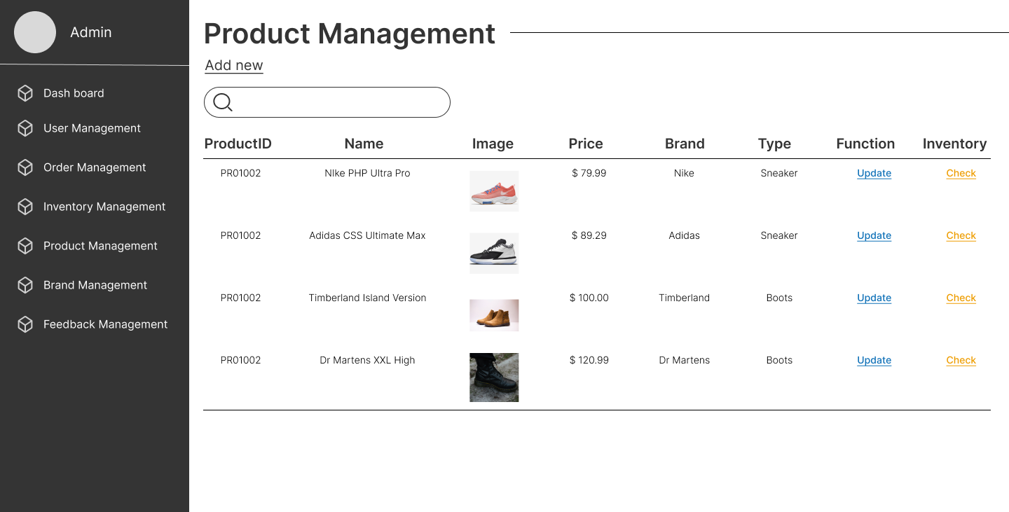

1. **Description**

**Description** : Product management, view product list

**From** : From menu product management

**To** : Update product information and add new product

**II. Add Product**

1. **Screenshot**

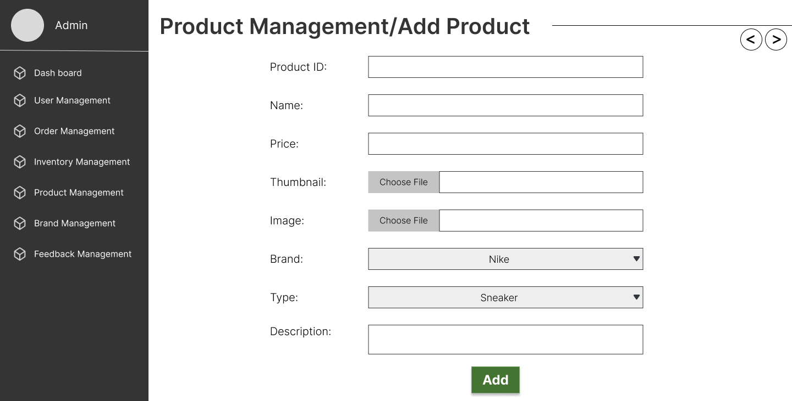

1. **Description**

**Description** : Add new product, all input fields must be filled, except Description. Product ID starts with ‘PRO’ and followed by 4 digit (example: PRO0034). Price greater than 0.

**From** : Admin menu

**To** : Go back to product management

**III. Update Product**

1. **Screenshot**

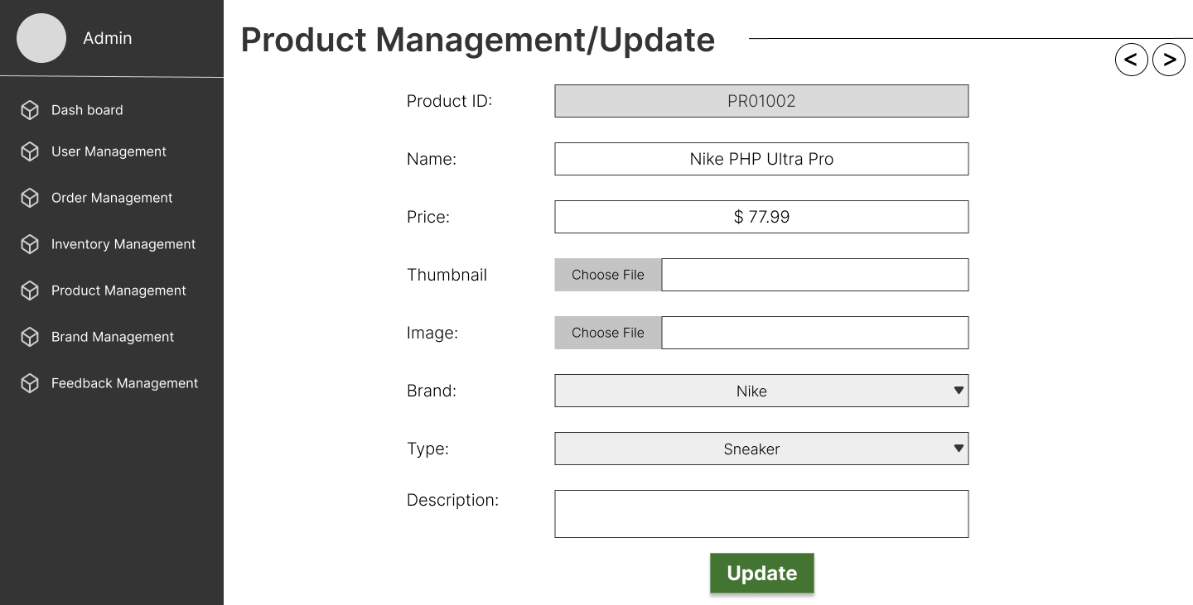

1. **Description**

**Description** : Update product information, only Product ID can’t change

**From** : Update in product management

**To** : Go back to product management

**IV. User Management**

1. **Screenshot**

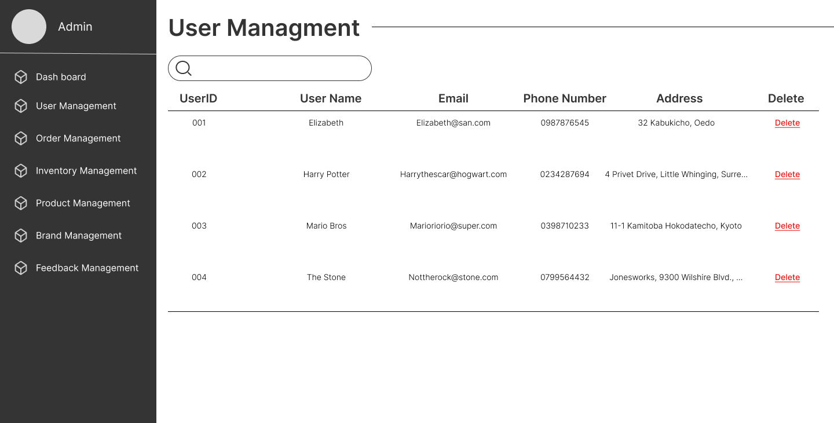

1. **Description**

**Description** : User Management, view list of users.

**From** : Menu User Management

**To** :

**V. Order Management**

1. **Screenshot**

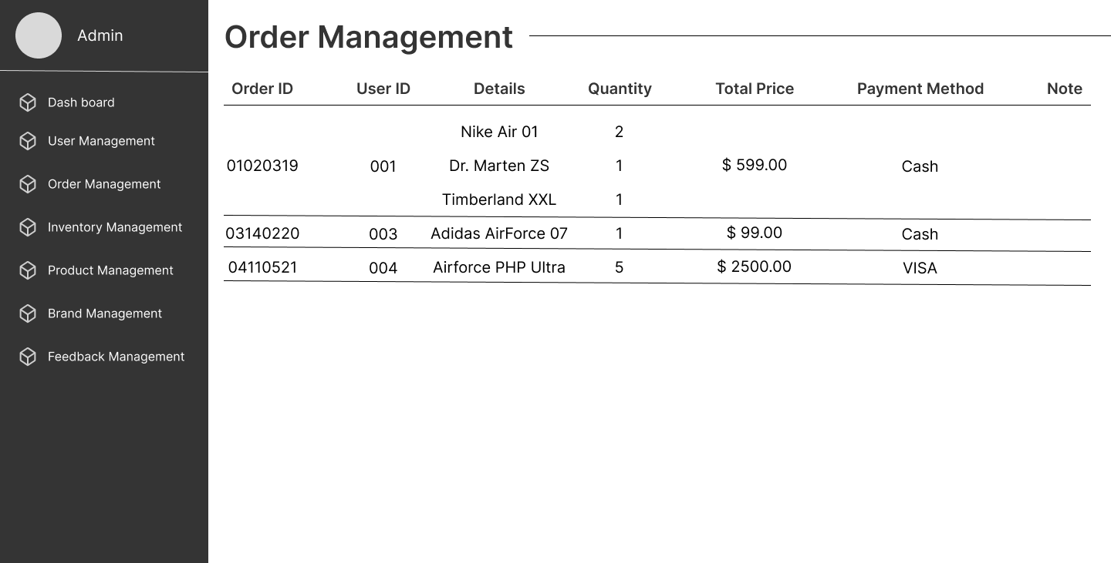

1. **Description**

**Description** : Order Management page, display list of orders.

**From** : Menu Order Management

**To** :

**VI. Inventory Management**

1. **Screenshot**

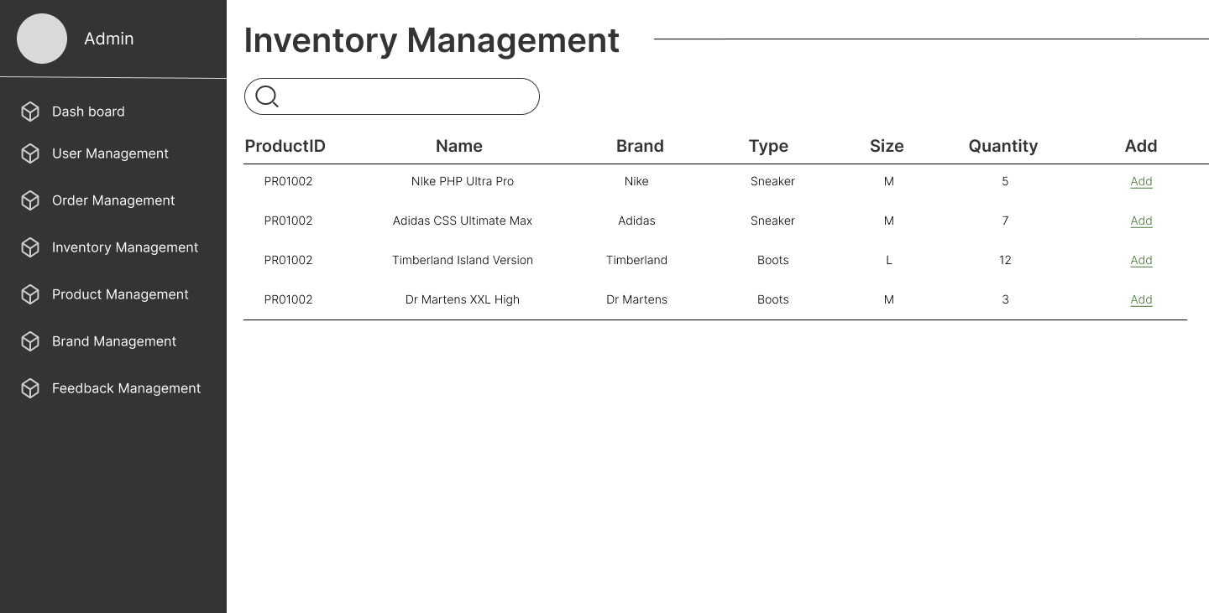

1. **Description**

**Description** : Inventory Management page, display quantity of products in inventory and add more quantity.

**From** : Menu Inventory Management

**To** : Add new quantiy of product page

**VII. Brand Management**

1. **Screenshot**

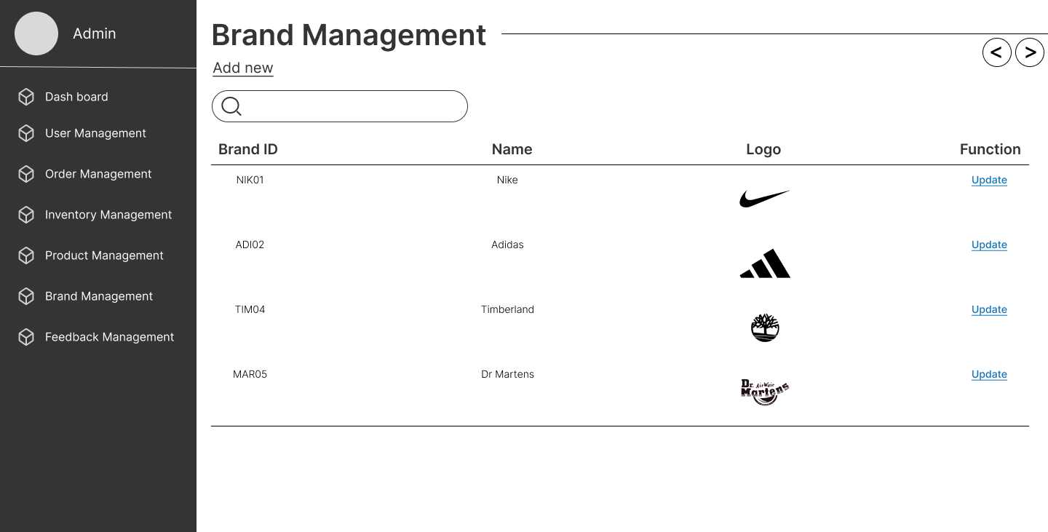

1. **Description**

**Description** : Brand management, view brand list

**From** : Admin menu

**To** : Add new brand, update brand information

**VIII. Add Brand**

1. **Screenshot**

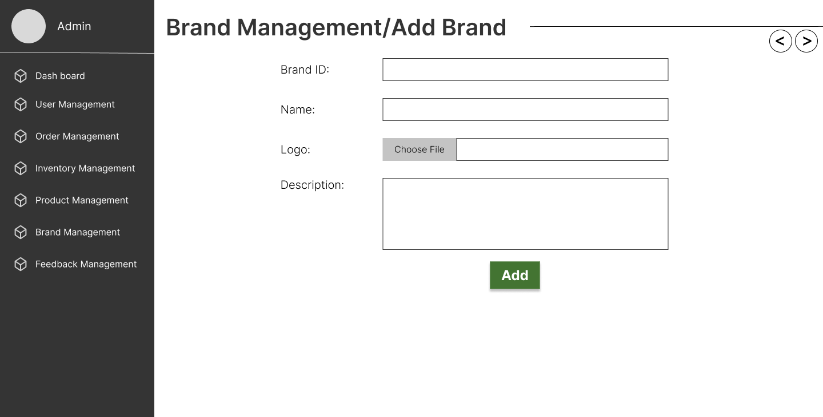

1. **Description**

**Description** : Add brand page, add a new brand

**From** : Brand management, brand list

**To** : go back to brand list.

**IX. Brand Update**

1. **Screenshot**

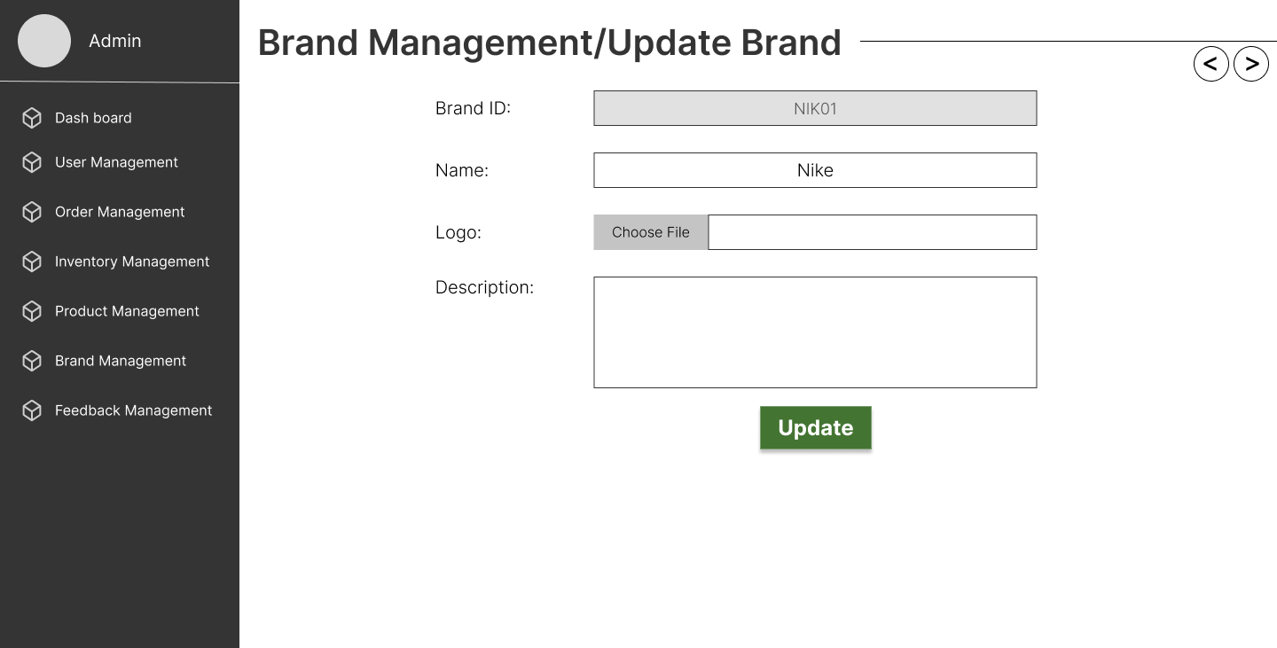

1. **Description**

**Description** : Update brand, update brand information. Brand ID cannot change.

**From** : Brand management, brand list

**To** : go back to brand list.

**X. Feedback Management**

1. **Screenshot**

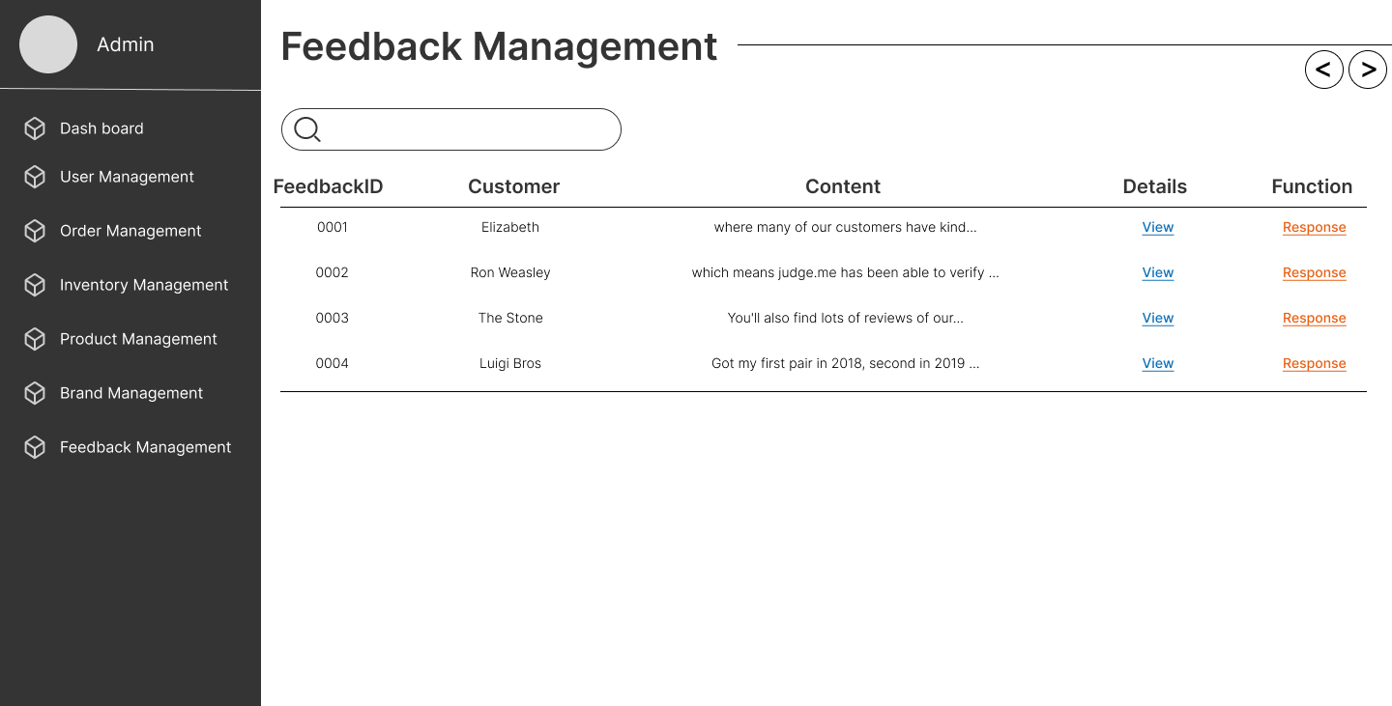

1. **Description**

**Description** : Feedback Management page, display feedback of users and guests

**From** : Menu Feedback Management

**To** : View Details feedback page

**XI. News Management**

1. **Screenshot**

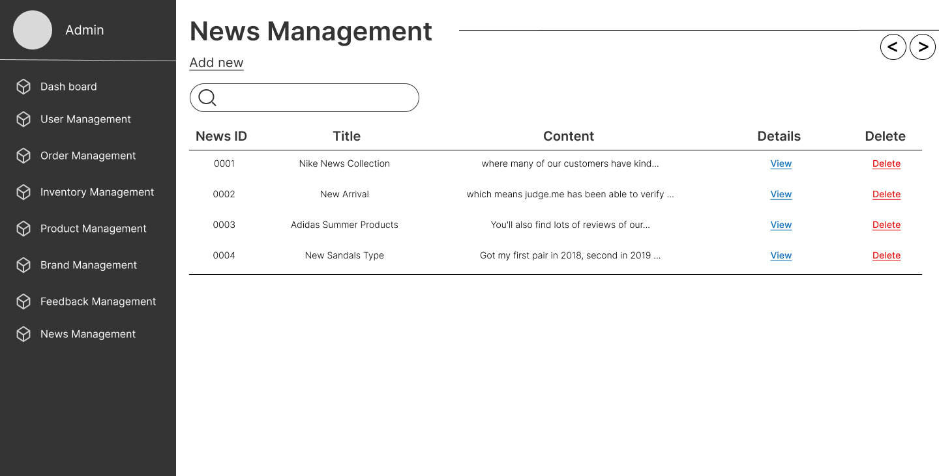

1. **Description**

**Description** : News Management page, display news in user pages.

**From** : Menu News Management

**To** : View Details News page, Add News page.

**XII. Add News**

1. **Screenshot**

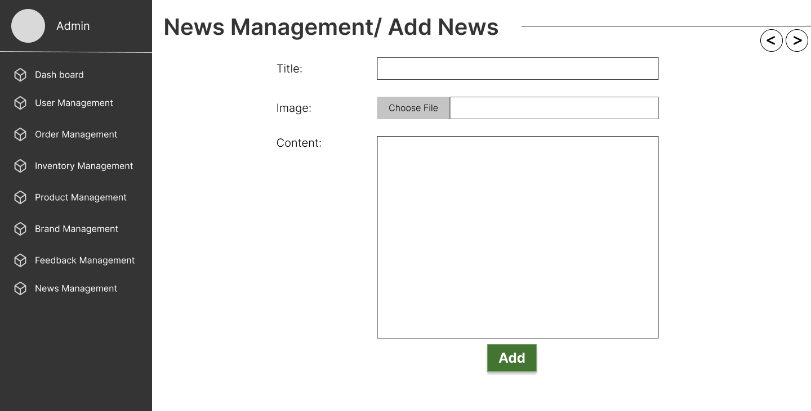

1. **Description**

**Description** : Add News page, all input fields must be filled.

**From** : Menu News Management

**To** : News List page.

|  |
| --- |
| **Testing document** |

|  |  |  |
| --- | --- | --- |
| **Sr.No** | **Features Tested** | **Remarks** |
| 1 | Are all the users able to view the products? |  |
| 2 | Is the application user-friendly? |  |
| 3 | Is the Website launching correctly in all popular browsers? |  |
| 4 | Are all the forms validated with proper criteria? |  |
| 5 | Do all text links lead to the appropriate website? |  |
| 6 | Do all image links lead to the appropriate website? |  |
| 7 | Are all the images and links clearly visible on the page? |  |
| 8 | Does the Web page work properly in all the tested browsers? |  |
| 9 | Is the navigation sequences correct through all the Web pages on the site? |  |
| 10 | Is the JavaScript code working as expected in all click events? |  |

|  |
| --- |
| **Final checklist** |

|  |  |  |
| --- | --- | --- |
| **Sr.No** | **Aspected Tested** | **Suggestion/**  **Remarks** |
| 1 | Are all the users able to view the images and links? |  |
| 2 | Have all the views, modules and controllers been properly integrated and is the site function as a single page application? |  |
| 3 | Are the GUI content devoid of spelling mistakes? |  |
| 4 | Is the application user-friendly? |  |
| 5 | Is the Website launching correctly in all popular browsers? |  |
| 6 | Are all the forms validated with proper criteria? |  |
| 7 | Do all text links lead to the appropriate website? |  |
| 8 | Do all image links lead to the appropriate website? |  |
| 9 | Are all the images and links clearly visible on the page? |  |
| 10 | Does the Web page work properly in all the tested browsers? |  |
| 11 | Does the Web page take too long to be loaded fully? |  |
| 12 | Is the navigation sequences correct through all the Web pages on the site? |  |
| 13 | Is the JavaScript code working as expected in all click events? |  |
|  |  |  |
|  | (Sinh viên ghi thêm…) |  |

|  |  |  |  |  |  |  |  |  |
| --- | --- | --- | --- | --- | --- | --- | --- | --- |
| **No** | **Member** | **Contents** | | **Table Name** | **Activity Plan** | **Date of Preparation of Activity Plan** | | |
| **Planed Start Date** | **Actual Start Date** | **Actual Days** | **Status** |
| 1 | **Hứa Lê Quang** | Admin | *Order Management* | tbOrder_Master,  tbOrder_Details | 26/10/2022 | 26/10/2022 | 5 | OK |
| 2 | 26/10/2022 | 26/10/2022 | 5 | OK |
| 3 | User | *Add Order* | 26/10/2022 | 26/10/2022 | 5 | OK |
| 4 | *User Order History* | 26/10/2022 | 26/10/2022 | 5 | OK |
|  |  |  |  |  |  |  |  |  |
| 1 | **Lê Vĩnh Phước** | Admin | *Comment and Rating Management* | comment,  rating | 26/10/2022 | 26/10/2022 | 5 | NaN |
| 2 | 26/10/2022 | 26/10/2022 | 5 | NaN |
| 3 | 26/10/2022 | 26/10/2022 | 5 | NaN |
| 4 | User | *Comment, Rating* | 26/10/2022 | 26/10/2022 | 5 | NaN |
|  |  |  |  |  |  |  |  |  |
| 1 | **Trần Hải Phong** | Admin | *Feedback and News Management* | tbFeedback, tbNews | 26/10/2022 | 26/10/2022 | 5 | OK |
| 2 | 26/10/2022 | 26/10/2022 | 5 | OK |
| 3 | User | *View News* | 26/10/2022 | 26/10/2022 | 5 | OK |
| 4 | *Send Feedback, View Feedback* | 26/10/2022 | 26/10/2022 | 5 | OK |
|  |  |  |  |  |  |  |  |  |
| 1 | **Trần Lê An** | Admin | *Product and Brand Management* | tbProduct, tbBrand | 26/10/2022 | 26/10/2022 | 5 | OK |
| 2 | 26/10/2022 | 26/10/2022 | 5 | OK |
| 3 | User | *View Product, View Brand* | 26/10/2022 | 26/10/2022 | 5 | OK |
| 4 | 26/10/2022 | 26/10/2022 | 5 | OK |
|  |  |  |  |  |  |  |  |  |
| 1 | **Trần Nam Trung** | Admin | *User and Address Management* | tbUser_Account, tbDelivery_Address | 26/10/2022 | 26/10/2022 | 5 | OK |
| 2 | 26/10/2022 | 26/10/2022 | 5 | OK |
| 3 | User | *Register, Add Address* | 26/10/2022 | 26/10/2022 | 5 | OK |
| 4 | *User Account Management* | 26/10/2022 | 26/10/2022 | 5 | OK |